Effects of a Ghrelin Receptor Agonist Administration in Chickens

4/30/2019

Table of Contents
Effects of a Ghrelin Receptor Agonist Administration in Chickens 1
1.0 Introduction 3
1.1 Structural Composition of Ghrelin 4
1.2 Expression of mRNA and Peptide in Chicken 4
1.3 Functionality 5
2.0 Abstract 7
3.0 Body: 8
3.1 Materials and Methods 8
4.0 Results and Discussion 9
5.0 Conclusion and Summary 13
References 14

1.0 Introduction
Ghrelin peptide in chicken consists of twenty-six amino acids, while mammalian Ghrelin is a twenty-eight peptide responsible for food intake stimulations (Sobrino Crespo et al., 2014). On the other hand, growth hormone triggers the intracellular calcium ion located in the cells to exhibit different receptors from Ghrelin (GHRL). Additionally, Ghrelin is responsible for cAMP accumulation. Significantly, ghrelin hormone receptors (GHSR) are expressed in the hypothalamus, pituitary gland, and peripheral tissues (Yin, & Zhang, 2014). Growth hormone is also expressed in the pituitary, hypothalamus, and peripheral tissues. For the production of the growth hormone, GHS combines with GHSR where the peptide has an N-terminal that manifests a unique feature due to the availability of the third amino acid that contains a modified fatty acid (n-octatonic acid). According to Bhattacharya et al., 2014 fatty acids play an indispensable role in the process of Ghrelin in chicken, preparing it for the next peptide activity. Ornithology reveals a particular Ghrelin modification birds’ bodies where Ghrelin presents itself in a similar molecular shape as in chickens, confirming the possibility of GHS-R in most birds. Also, this molecule can be confirmed by segregating the peptide away from the chicken proventriculus.
In birds, Ghrelin is different from mammalian species in terms of amino acid numbers. Ghrelin in chickens consists of 26 amino acids, while mammals consisted of 28 amino acids (Tachibana, & Tsutsui, 2016). According to Takahashi et al., 2014, the ghrelin gene in chicken contains four introns and five exons. (Takahashi et al., 2014). Despite that, tonly exon two and exon five are used during preproghrelin encoding.

1.1 Structural Composition of Ghrelin
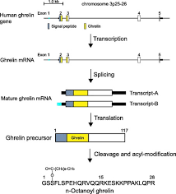
(American Journal of Philosophy, 2019. pg54-58)

1.2 Expression of mRNA and Peptide in Chicken
In chickens, the distribution of ghrelin mRNA contains large quantities in the upper part of the proventriculus, except for the gizzard. Using RT-PCR, all levels are analytically monitored, involving the mRNA expression systematically from the brain down to the interstices in layers or boilers (Kitazawa et al., 2015). Since ghrelin synthesis sites are typical for both layers and boiler, it enables mRNA to manifest in the process of growing and hatching—the mucosal layer stores ghrelin in cells. The production of Ghrelin is done by the enteroendocrine in the gastrointestinal tract more often in the proventriculus, and therefore it increases the intake of food. Ghrelin assists in the preparation of feed intake in chickens by increasing the secretion of gastric acid and gastric motility.

1.3 Functionality
In mammals, ghrelin functions as an orexigenic hormone. When Ghrelin is injected centrally and peripherally, it triggers appetite and increases the feed intake. However, intracerebroventricular injection GHS in neonatal chicks decreases feed intake (Howick, Griffin, Cryan, & Schellekens, 2017). Research conducted on the feed intake and diet energy in chickens has reported ghrelin agonist feeding in chicken during central ghrelin administration (Classen, 2017). Conversely, some revealed that ghrelin administration does not affect feed intake in the chicken, while other experiments show inhibition of feed intake after administering Ghrelin (Sintubin, 2014). However, peripherally ghrelin administration in chickens triggers GH release that escalates appetite foster in feed intake. However, the effect of a ghrelin agonist given as an oral lavage in chickens has not been evaluated. The objective of this experiment was to assess daily doses of Entyce (a ghrelin receptor agonist) in chickens.
Figure 1: Ghrelin in birds

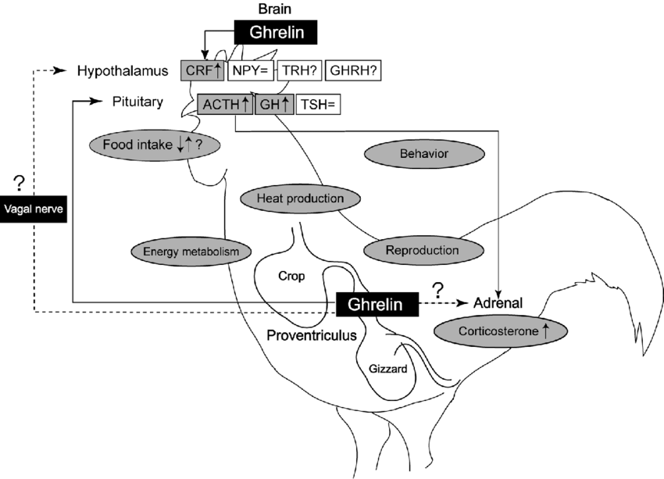
From the above figure, Ghrelin in the brain inactivates the cells in the hypothalamic arcuate nucleus and the pituitary gland. This incorporates the neuropeptide Y neurons. Consequently, brain structures with the secretagogue growth hormone are stimulated, initiating appetite. In return, it regulates glucose metabolism, reward behavior, sleep-wake cycle, reproduction system, and sensation of taste.

2.0 Abstract
It is the desire for every producer to practice economic farming, leading to a profitable income. A new scientific approach to poultry farming has recently increased production compared to the traditional poultry production methods (Pomalégni et al., 2017). Scientific poultry farming requires farmers to ensure moderated intake of nutrients in their farms for efficient poultry production. Consequently, there is a need for regulating food intake by triggering and elevating levels of food consumption in chickens, which in return, results in fast growth. To be specific, according to Pomalégni et al., 2017 Ghrelin, which is generally viewed as a stomach hormone, has been used in chickens to improve the productivity of the farm. Ghrelin (peptide hormone) in chicken consists of twenty-six amino acids. The 26-amino acid peptide can be described as an endogenous ligand from a ghrelin agonist coupled receptor (GPCR), leading it to be termed as a growth hormone secretagogue receptor (GHSR); a synthetic compound with GH-production activity (Khatib et al., 2014). We experimented using a ghrelin agonist, known as Entyce, in six birds. Entyce was given orally every morning at 7:00 A.M. for five days. In those five days, we measured feed intake at 7:00 A.M, 12:00 Noon, and 5:00 P.M. We weighed and recorded their feed intake before refilling and after refilling. By recording their feed intake, we were able to calculate and analyze how much feed was consumed. Attached below is a picture of the structural composition in Ghrelin.

3.0 Body:

3.1 Materials and Methods
We will be administering entice orally in six birds for five days, repeatedly for five weeks. We want to see if Entice will have an effect on the chicken’s appetite over time. Also, we will be using the SAS program to analyze our data.
We obtained the birds from a hatching company, and upon arrival, they were placed in brooders. When they were about six weeks of age, they were transferred to cages and sorted into three treatments. During the experiment, three treatments were randomly assigned to six birds. Birds on treatment 1 received 6mg/kg of BW of Entyce as an oral lavage. Conversely, birds on treatment 2 received 12mg/kg of Entyce into each bird mouth. Next, water was given to the birds after the Entyce. We then weighed and recorded the feed intake after the refill. We chose to use repeated measurements for our experimental design. Repeated measures refer to data sets with multiple sizes of a response variable on the same experimental unit. In repeated measure experiments, we are interested in whether the treatment will change over time or if there will be a treatment-by-time interaction.
Additionally, we prepared an appropriate SAS program to evaluate our data. The procedure we chose to use to analyze the data was proc mixed. We evaluated four different covariance structures to select the most appropriate covariance structure. After running the SAS program, we discovered that the AR (1) would be the superior covariance structure to use. The AR (1) covariance structure has the smallest values of the criteria, which is considered the most desirable.
Table 1: Fit Statistics for the 4-Covariance Structures
Fit Statistics
Structures | AR (1) | TOEP | CS | ARH (1)
AIC (Smaller is Better) | 152.0 | 155.5 | 153.6 | 155.1
AICC (Smaller is Better) | 152.8 | 163.2 | 154.4 | 166.3
BIC (Smaller is Better) | 151.5 | 154.3 | 153.2 | 153.6

4.0 Results and Discussion
Table 2: Indicates the factor(s) or interactions among the covariance structures to make inferences on which covariance is significant in this experiment (using an alpha of 1%).
Structures | AR (1) | TOEP | CS | ARH (1)
TRT | 0.2303 | 0.5538 | 0.4515 | 0.2707
DAYS | <.0001 | 0.0002 | <.0001 | 0.0007
TRT*DAYS | 0.6635 | 0.5714 | 0.5701 | 0.8501

$$H0: Treatment 0=Treatment 6=Treatment 12$$
$$HA: Treatment 76≠Treatment 77≠Treatment 78≠Treatment 79≠Treatment 80≠Treatment 81$$
Based on our results, there was a day effect. We discovered that there was no interaction between the treatment and the days. We reject the null hypothesis and accept the alternative hypothesis.
Step 1: Calculate differences between treatments means to determine which ones are significantly different from each other.
Note: NS stands for not significantly different.
Note: **p˂0.05 (differences)
D0 vs D1 NS | D1 vs D2 ** | D2 vs D3 ** | D3 vs D4 NS | D4 vs D5 NS
D0 vs D2 ** | D1 vs D3 NS | D2 vs D4 ** | D3 vs D5 NS
D0 vs D3 NS | D1 vs D4 NS | D2 vs D5 **
D0 vs D4 NS | D1 vs D5 NS
D0 vs D5 NS

Step 2 and 3: Label each line with lowercase letters.
Tukey-Kramer Grouping
for Days Least Squares
Means (Alpha=0.05)
LS-means with the
same letter are
not significantly
different.
Days | Estimate
D2 | 76.6667 | A
D3 | 41.6667 | B
 |  | B
D5 | 38.3333 | B
 |  | B
D4 | 33.3333 | B
 |  | B
D1 | 26.6667 | B
 |  | B
D0 | 21.6667 | B

Figure 1: The effect of ghrelin agonist (0, 6, 12 mg/kg) on feed intake (g) in male broiler chickens (p˂0.05).
The purpose for this research was to see if ghrelin agonist Entyce would increase chicken’s appetite. In the graph, the letters represent whether the feed intake was different, or not different between days. If the days share the same superscript, that means there is no difference in feed intake. In figure 1, the results displayed that by using Entyce had no effect on the chicken’s appetite over time. However, on day two, they consumed more feed than any other day. We are not sure why this happened. Entyce is still a substantial ghrelin agonist to use, but it might be better to add it in the water or by injecting for better results. Also, research has revealed the adaptation in the chicken's body, that aid in making Ghrelin effective. The brain is showed to be the primary receptor for all ghrelin administration. Besides, research has revealed that the two-mode of administering Ghrelin in chickens are intracerebroventricular injection and peripheral injection. Intracerebroventricular injections inhibit food intake, while peripheral injections accelerate food intake.

5.0 Conclusion and Summary
There was no treatment effect but there was an increase in feed intake on day 2.

References
Bhattacharya, S. K., Andrews, K., Beveridge, R., Cameron, K. O., Chen, C., Dunn, M., & Khot, V. (2014). Discovery of PF-5190457, a potent, selective, and orally bioavailable ghrelin receptor inverse agonist clinical candidate. ACS medicinal chemistry letters, 5(5), 474-479.
Classen, H. L. (2017). Diet energy and feed intake in chickens. Animal Feed Science and Technology, 233, 13-21.
Howick, K., Griffin, B., Cryan, J., & Schellekens, H. (2017). From belly to brain: targeting the ghrelin receptor in appetite and food intake regulation. International journal of molecular sciences, 18(2), 273.
Khatib, N., Gaidhane, S., Gaidhane, A. M., Khatib, M., Simkhada, P., Gode, D., & Zahiruddin, Q. S. (2014). Ghrelin: Ghrelin is a regulatory Peptide in growth hormone secretion. Journal of clinical and diagnostic research: JCDR, 8(8), MC13.
Kitazawa, T., Hiraga, T., Teraoka, H., Yaosaka, N., & Kaiya, H. (2015). Correlation of ghrelin concentration and Ghrelin, ghrelin-O-acetyltransferase (GOAT) and growth hormone secretagogue receptor 1a mRNAs expression in the proventriculus and brain of the growing chicken. Peptides, 63, 134-142.
Miska, K. B., Fetterer, R. H., & Wong, E. A. (2014). The mRNA expression of amino acid transporters, aminopeptidase N, and the di-and tri-peptide transporter PepT1 in the embryo of the domesticated chicken (Gallus gallus) shows developmental regulation. Poultry Science, 93(9), 2262-2270.
Pomalégni, S. C. B., Gbemavo, D. S. J. C., Kpadé, C. P., Kenis, M., & Mensah, G. A. (2017). Traditional use of fly larvae by small poultry farmers in Benin. Journal of Insects as Food and Feed, 3(3), 187-192.
Sintubin, P., Greene, E., Collin, A., Bordas, A., Zerjal, T., Tesseraud, S., & Dridi, S. (2014). Expression profile of hypothalamic neuropeptides in chicken lines selected for high or low residual feed intake. Neuropeptides, 48(4), 213-220.
Sobrino Crespo, C., Perianes Cachero, A., Puebla Jiménez, L., Barrios, V., & Arilla Ferreiro, E. (2014). Peptides and food intake. Frontiers in endocrinology, 5, 58.
Tachibana, T., & Tsutsui, K. (2016). Neuropeptide control of feeding behaviour in birds and its difference with mammals—frontiers in neuroscience, 10, 485.
Takahashi, H., Rikimaru, K., Komatsu, M., Uemoto, Y., & Suzuki, K. (2014). Association between motilin receptor gene haplotypes and growth traits in Japanese Hinai-Dori crossbred chickens. Asian-Australasian journal of animal sciences, 27(3), 316.
Yin, Y., Li, Y., & Zhang, W. (2014). The growth hormone secretagogue receptor: its intracellular signalling and regulation. International journal of molecular sciences, 15(3), 4837-4855.

